DEFACTO Morphing Database

Gracy Jason Joseph  
 Data and Knowledge engineering  
Otto-von-Guericke university  
 Magdeburg, Germany  
 gracy.joseph@st.ovgu.de

Shweta Pandey  
 Data and Knowledge engineering  
 Otto-von-Guericke university Magdeburg, Germany  
 shweta.pandey@st.ovgu.de

*Abstract*- There have been various approaches for generation of doctored images through different techniques. In this paper, we have created an analysis and classification of the morphed images which are created by morphing two genuine images together.

**Images are morphed by some forgeries categories namely Copy & Move, Splicing, Object Removal and Morphing. We have used Morphing as a forgery technique for experimenting with the images.**

**In this Morphing technique there are 3 methods which are mainly used, such as combined, splicing and complete. With that we have calculated and analyzed the scores fetch through Biometric analysis and for the quality check we have made use of forensic analysis.**

*Keywords-* Forgeries, combined, splicing, complete, alpha, morphed, evaluation, Dermalog matcher, Detector, ANANAS web service.

1 INTRODUCTION

Morphing is a technique which gives a transition to one image from another. Hence it is a fluid visual transformation of one to an another image. **[1] A Survey of Morphing Techniques**

Its been used in many Hollywood films or in gaming purposes in video or computers and in creating animated movies. However, morphing technique is not limited for the above purposes, instead it is a powerful technique that intensifies multiple multimedia projects such as presentations, e-book illustrations etc.

Morphing technique has been rapidly increasing and it has become very easy for anyone to create a doctored image and use it for any purpose. It is increasing crimes, fake identity, impersonation et al. The morphed images can be used by an imposter to sham the identity; hence it is very crucial to detect these type of scammers.

Morphing is a procedure between two genuine images, where in first the specification of the correspondence point is initiated which is also called as 'feature specification'. Then the feature primitive of both the images is processed, which is mostly a manual work. After which each primitive denotes the image landmark and then corresponding features of mapping function is reckoned. Basically morphing process is a three phase technique mainly consists of feature specification, warp generation and transition control**. [1] A Survey of Morphing Techniques**

Numerous techniques have been made available for the detection of the doctored or morphed images and various categories have been used to analyze them. While morphing, many parameters are being taken into consideration, such as setting up alpha parameter, setting up methods to blend the images.

We have used a DEFACTO dataset to study wide range of forgeries. DEFACTO dataset is publicly available and it is been used widely to compare the results. **[2] mahfoudi**

This dataset has been used for the experimentation purpose meant to study doctored images and to analyze them. We have created many morphed images for each of the methods by using ANANAS web services.

**2 DATASET OVERVIEW**

The images that we have collected is from the DEFACTO dataset which is publicly available for experimentation purpose.

The DEFACTO database consists of 200 genuine images and their morphed images.

*2.1 Forgeries technique*

here are four major categories of forgeries namely copy-move, splicing, object-removal and morphing.

Copy-move is the forgery technique which consists of the duplication of a particular element inside the image. Splicing is a method wherein one part or portion of an image is copied and added to the other image. In the object-removal technique, a part or a whole object is removed from an image by the use of an algorithm. While in morphing, warping and blending are the two processes which is used in two images together.

In each of the above techniques there is a post processing which is applied such as rotation, scaling, contrasting et al. An image composite can be most likely a formation of the basic operations. Hence detection of these categories would be lot more different.

*2.2 Method used in our experiment*

In our case, we use the method of morphing. In morphing technique when 2 images are being transformed, there are multiple intermediate images that are created. The first intermediate image would be similar to the first image and the last intermediate image would be similar to the second image. The one which is in the middle is the 50:50 of both the faces. We have the images which would be taken from the DEFACTO database and then it would be morphed by using ANANAS web service.

After which we can start our experiment by analyzing these images through Biometric and Forensic analysis.

There are some forgeries which could be easily detected by human eyes. But we wanted to create some datasets which would be challenging for us to detect.

**3 EXPERIMENT**

*3.1.* *Morphing Technique*

We considered two original images from DEFACTO database. This database has front facing images of artists with a very neutral expression as the base to create face morphing forgery. It has a total of 200 images. It also has images which are morphed already. We need to create their morphs and would be analyzing them.

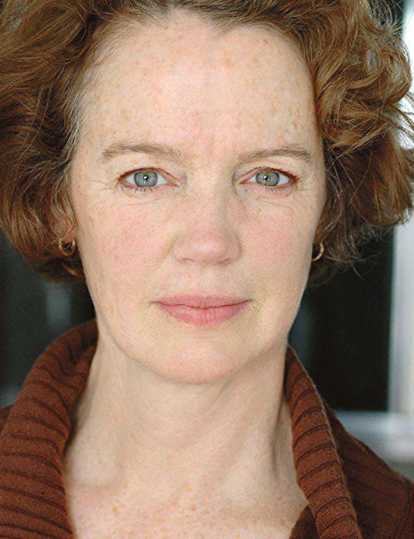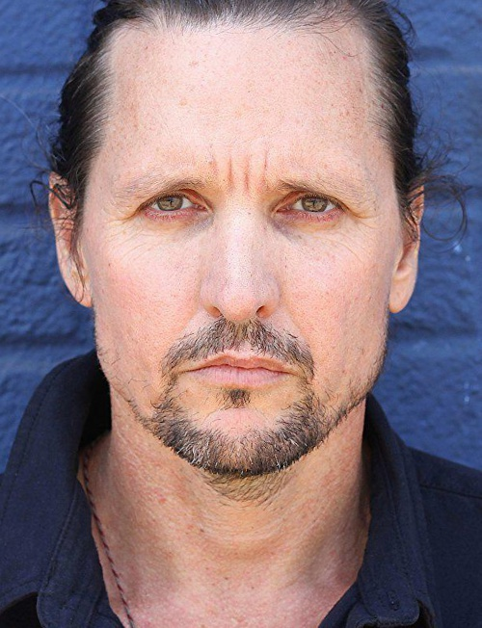

Face A Face B

*Fig:* *Genuine images from DEFACTO database*

The face morphing process can be seen on the images, taking 2 original images and using the parameter landmarks to extract a set of facial landmarks and with that according to the image the first roughly alignment begins with the eyes, then a weighted factor/parameter alpha α ∈ [0,1] is taken into consideration of the two images and then the with the landmarks computation, the two images are blended with a precise alignment. Post the two images are α (alpha) blended with a factor, there is a local scaling performed for the better skin tone. The alpha factor is needed to decide which particular face's structure should be more visible.

In our case, we have taken only alpha factor into experiment as it gave us the proper morphed picture. And as there are methods into morphing we have taken each methods with the parameters.

*A.* *Combined Method*

The images are first morphed using combined method with alpha parameter as 0.5 which means that 50% of face A and 50% of face B has to be taken.

With this the result image should be a 50:50 ratio of both. The alpha factor 0.5 is the average point that we have taken. The images are blended according to the parameters set. The color balances, facial structure is then produced accordingly.

Below is the morphed image through combined method.

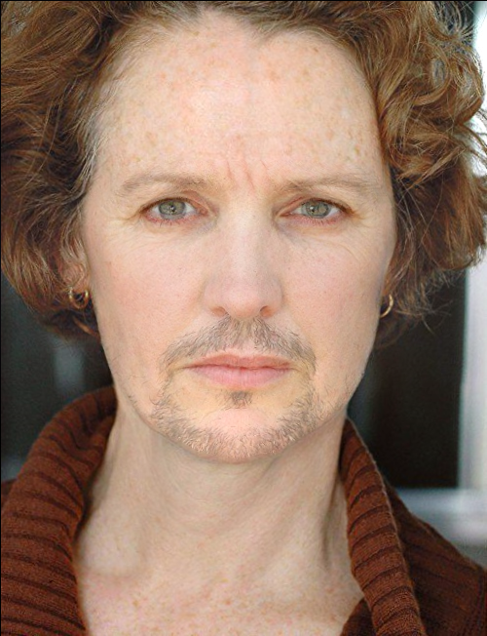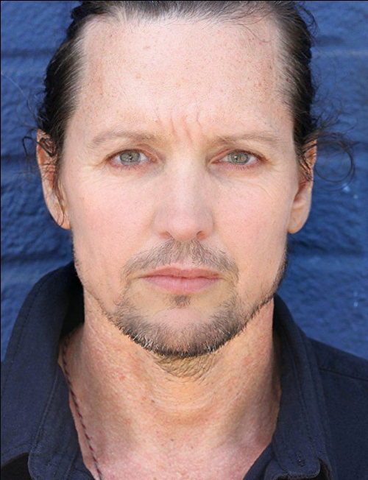

Morph A Morph B

*Fig:* *Morphed images created through ANANAS web service*

*B.* *Splicing method*

The images are then experimented with the second method of morphing called splicing. We have taken the alpha parameter as 0.5 to check how the final result looks like. The images created by splicing wont be similar to combined method.

The images give the result from warping and blending of the facial regions with the subsequent adding into one of the original backgrounds. It makes the images clear of ghosting artifacts. [] Andrey

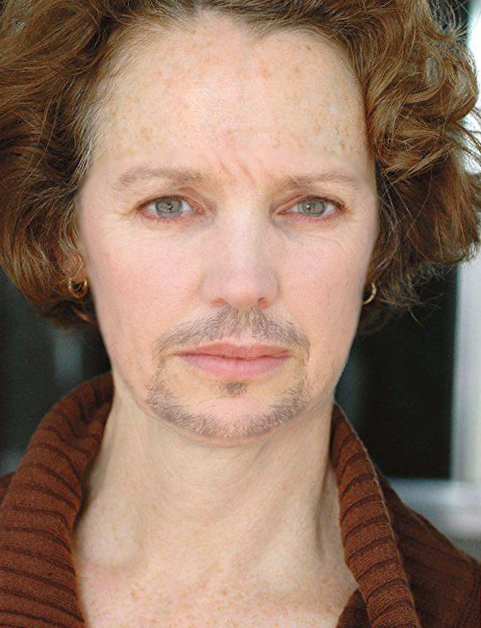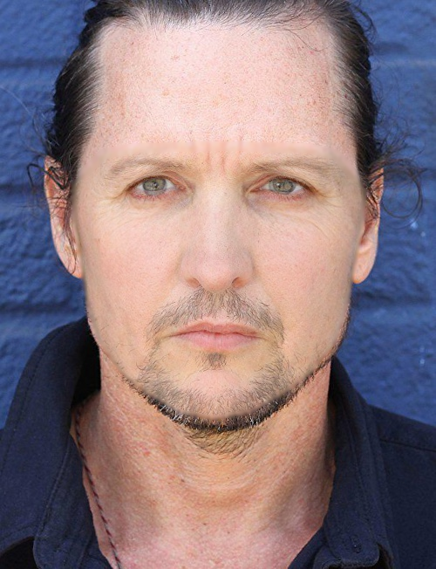

Morph A Morph B

Fig: Morphed images created through ANANAS web service

*C.* *Complete method*

Complete is the third method of morphing which doesn’t give a perfectly blended image. But it shows us the color association, the points where the two images would be blended and how.

The result is not a perfectly doctored image but it gives the middle transition of both the images. It gives the 50:50 image of both.

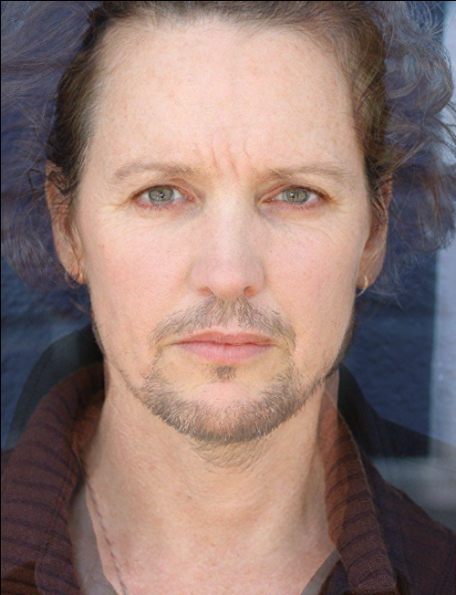

Transition image

Fig: Transitioned image created through ANANAS web service

*3.2* *Biometric analysis*

Biometric quality is one of the three-folds in which a morphed image should be successfully verified by any AFR-system (automated face recognition) against its own original image*.* ***[] IET-BMT19_Neubert***

The biometric quality and a particular AFR system show the quality in terms of error rates in a system. The greater the error rates, there would be a higher chance of the biometric quality of the doctored image.

In our case, we took the method Dermalog face recognition in Biometric analysis. It is the technique that combines the biometrics of facial structure. Specially with the combination with ID cards, it is able to properly verify that the person with the information matches the given identification documents.

This particular technique operates reliably in various conditions such as age, gender, size, contrast, light, color etc. It is also used as a part of border control in most of the countries, hence it is quite reliable and gives a good verification rate.

We have used this method in order to get the verification score of the self-created morphed image, to know if it gives a proper evaluation result.

For a better score, we have taken the threshold score more than 80.



Face A Morph A (combined)

*Fig:* *The scores from first original image and morphed image from combined method*

In the above experiment, we have used matcher and we got the score of 99 and the evaluation was a Match.

That means the Morphed image has captured the facial features of the genuine image.

Post this, matcher technique is used on original face B and second morphed image by combined method.



Face B Morph A (alpha:0.5) Morph A (alpha:0.7)

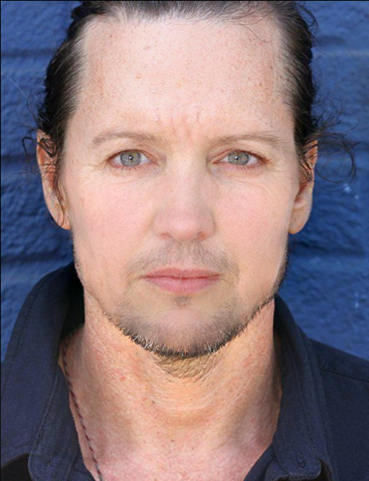

*Fig:* *The scores from second original image and morphed images from combined method*

In the above experiment, we have used matcher and we got the score of 59.01 and the evaluation was a NoMatch.

That means the percentage of facial features captured by the Morphed image from the genuine image B is less.

We then altered the alpha value from 0.5 to 0.7 and then we got the score as 92.64 and the evaluation as a match, which means now the morphed image has captured the features with the maximum percentage.

**ORIGINAL**

**COMPLETE**

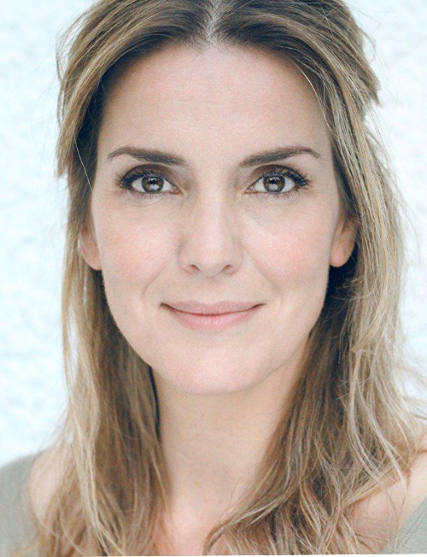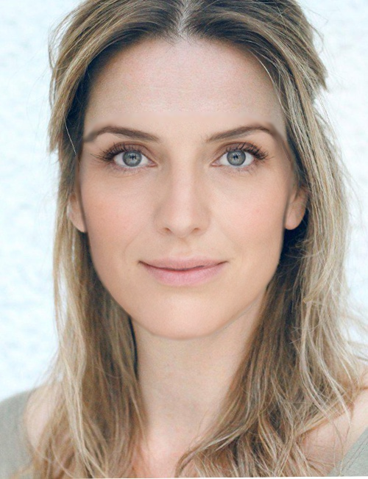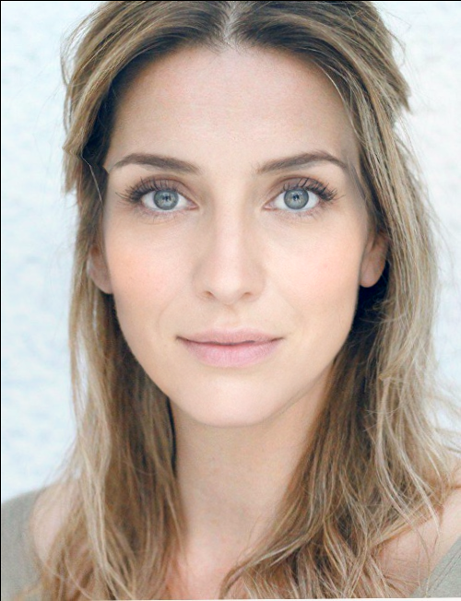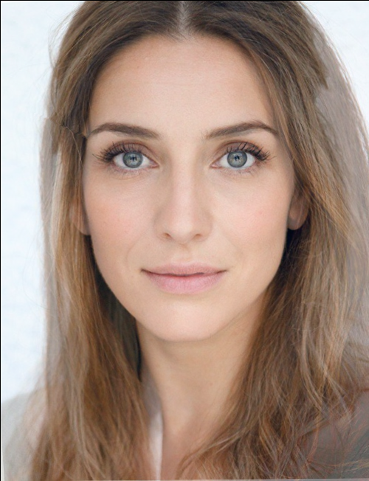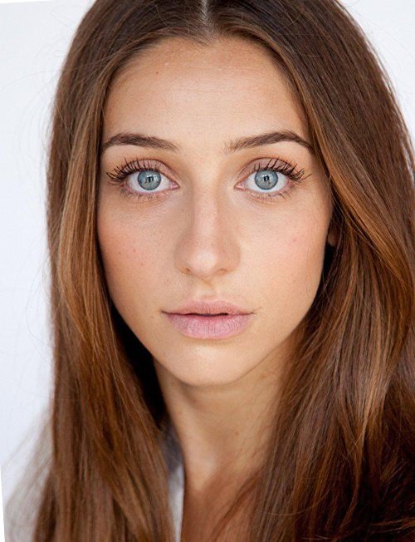

Genuine Image 1

A blend of 2 images

Combined Morph 1

Splicing Morph1

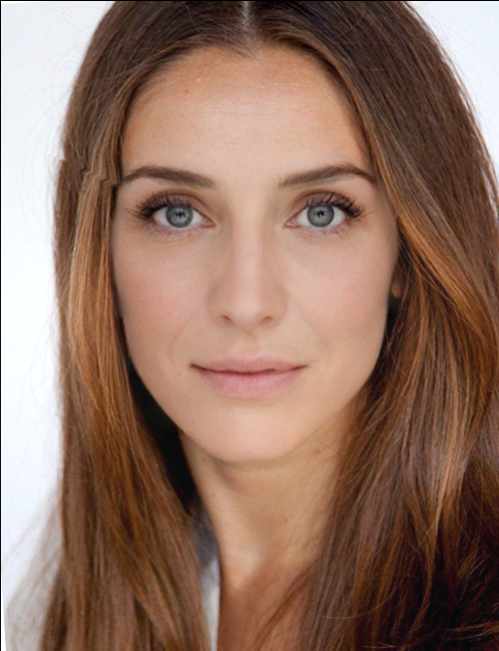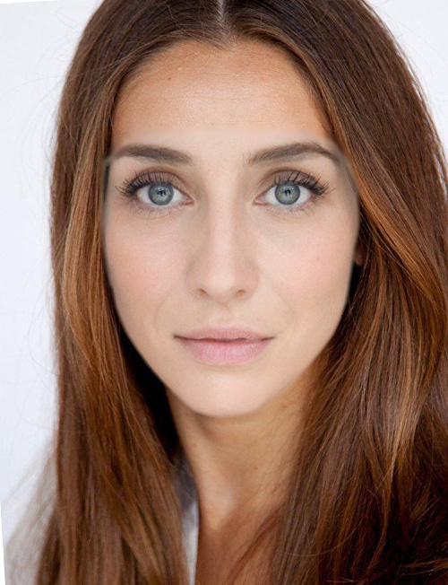

Splicing Morph 2

Combined Morph 2

Genuine Image 2

**COMBINED**

**SPLICING**

*Fig.: Example of morphed/doctored images: complete, combined and splicing approaches; original images are from DEFACTO database*

In this case, we are experimenting in making such a morphed image which cannot be detected. There are times when after taking the alpha factor 0.5 the image doesnt turn out to be a good doctored image, that means the score is less than the threshold value.

It means it’s not a better morphed image of the original and has not captured that percent of facial features of the original image.

Here we have played with the factor value, till we get a perfectly morphed image. Dermalog face recognition method is used to compare the original to the other morphed image. Through Matcher we got the scores of both the images.

The threshold score which we used for analyzing was 80 and the evaluation result as match. If incase the score was below 80, we made it sure we morph the image in such a way that the score reaches the threshold value with match as the evaluated result. We have done this, in order to get a perfectly morphed image so that we can experiment it to find

the analysis if it really gives us a better result in finding a doctored image. The score that we got after comparing the original image with its morphed image was 59.01 which was less than our threshold value of 80. We then changed the alpha factor to 0.6 then 0.7 till we get a perfectly morphed image with the evaluated score greater than the threshold value.

Now we have performed the same technique for the 2 genuine images with the second morphed image created by combined method.



Face A Morph B (combined)



*Fig:* *The first original image and morphed images created from combined method*



Face B Morph B (combined)

*Fig:* *The and second original image and morphed images created from combined method*

The second morphed image was compared with both the genuine images, and the scores were above the threshold value 0.80, so we didn’t alter any factors.

The same way we have performed the alteration of samples which aren’t higher than the threshold value. And it is done on the morphed images made through splicing and combined.

*3.3 Forensic analysis*

Forensic analysis means that the morphed images which do not have the forensic traces of illegitimate procedures of image editing. **[] IET-BMT19_Neubert**

Forensic is similar to biometric analysis as here the forensic quality is linked to the error rates of the morph detection procedure. There are two samples, positive and negative. In which the positive sample is the morphed image and negative sample is the original image.The higher the rate of the error, the higher the forensic quality of the doctored image. The simpler term of forensic analysis means a detailed investigation by means of detecting.

For eg, in case of the passport checking, the analysis of the printed image is carried out and scanned in the application procedure for the further detailed investigation or off-line authenticity. **[] debiasi 19c**

There are issues/ attacks wherein the attackers try to divert various forensic procedures and dissemble their counter-forensic procedures for which methods are created to reveal such atrocious attacks.

In our experiment, we have used detector methods like Keypoints, GoogleNet-based, Benford, Degradation, VHH 19-based (naïve and multi-class) and High-Dim LBP.

Each of the detector methods were used in different methods of morphing.

For eg,

For a morphed image created through combined method, we have used these detector methods as a forensic analysis to detect a score, which gives us the rate as to how a particular morph is detected and evaluated.

We have taken the 3 methods Keypoints, Degradation and Benford through OvGU and we have decided a threshold score of 0.5.

That means if a morphed image has been detected with a score more than 0.5, then that particular image is Morphed and if its not then that image is not morphed. Basically, a morphed image when it is created is so much precise, that it is not possible to detect it by simpler means. It has to be detected to prevent forensic attacks.

Hence we have come up with an experiment, in which the morphed image which we have created is been detected by all the three methods of detectors and then based on the threshold value, the evaluation has been made. In simpler terms, it helps to identify if a given image is morphed or no. There were so many detector methods, hence, we used three of them and then made it in a tabular format so that we can classify them in a proper way and know which detector can be the best.



Morph A (combined)

|  |  |  |
| --- | --- | --- |
| **Detector Methods** | **Score** | **Evaluation** |
| **Keypoints** | 0.56 | Morph |
| **Benford** | 0.99 | Morph |
| **Degradation** | 0.53 | Morph |

*Table 1:* *The detector methods are being analysed with their respective scores for a morphed image created by combined method*

|  |  |  |
| --- | --- | --- |
| **Detector Methods** | **Score** | **Evaluation** |
| **Keypoints** | 0.25 | NoMorph |
| **Benford** | 0.99 | Morph |
| **Degradation** | 0.50 | Morph |

**

Morph A (splicing)

*Table 2:* *The detector methods are being analysed with their respective scores for a morphed image created by splicing method*

In the table 1, all the scores being more than 0.5 threshold, is being evaluated as morphed and in table 2 it shows, the scores less than 0.5 is evaluated as NoMorph, that means even though the image could be a morphed image then detector can not detect them as morphed.

Like this, we have calculated the scores and evaluation of all the morphed images created by morphing techniques and categorized them.

For the above, the tabular format is only for a single image, but for the bulk morphed images that we have created, to be precise, we have found the error rate and the accuracy of the detectors with respect to the original images from the DEFACTO so that we can get a clear picture of which method gives an average best score from the rest. **(link the one which Shweta will add)**

**4. ANALYSIS AND VISUAL CLASSIFICATION**

As we were able to morph the original images from DEFACTO dataset using ANANAS web service (AWS). And by means of combined and splicing method, we were able to create them, the morphs which is created by us using AWS is being visually compared with the already morphed images of DEFACTO database.

This subjective visual comparison shows us the way the morphs are been generated and by what means they are indifferent to each other. The analysis of the entire dataset is been carried out by comparing it visually by checking their eyesight, their transitions, facial structure which includes prolonged face, oval face etc, or the skin texture, jaw line, double chin et al. If there are no visual differences, there could be a severe loss of quality loss of the images because of its compression. The morphs may also contain shadow artefacts. There would be some morphed images which are elongated or oval in shape than the other, or else the skin color would differ.

There are some examples shown below post the visual comparison.

The comparison of morphed image created by combined and splicing method through AWS with the morphed image from DEFACTO database. This is only to analyse which morphed image is precise or can be used for the task.

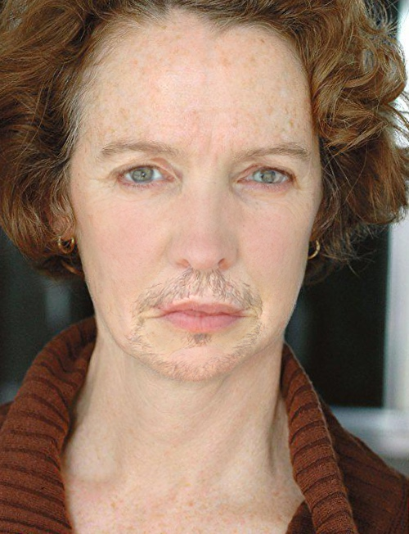

Morph B (combined)

ANANAS web service

Morphed Image

(DEFACTO Dataset)

*Fig:* *Morph B is the morphed image created by ANANAS web service using combined method of morphing, whereas the other image is the morphed image from the DEFACTO dataset*



Morph B (splicing)

ANANAS web service

Morphed Image

(DEFACTO Dataset)

*Fig:* *Morph B is the morphed image created by ANANAS web service using splicing method of morphing, whereas the other image is the morphed image from the DEFACTO dataset*

These comparisons are being visually analysed for both the morphs created by combined and splicing.

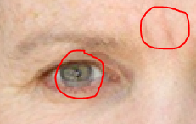

1. Morph B (combined)

ANANAS web service

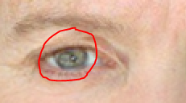

(b) Morphed Image

(DEFACTO Dataset)

*Fig:* *Differences between the two morphed images from ANANAS web service and DEFACTO dataset (eye)*

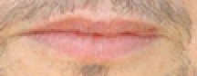

1. Morph B (combined)

ANANAS web service

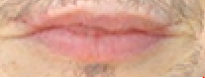

(b) Morphed Image

(DEFACTO Dataset)

*Fig:* *Differences between the two morphed images from ANANAS web service and DEFACTO dataset (lips)*

After visually comparing both the morphed images created by combined method to the morphed image by DEFACTO, here are some of the differences:

* Difference in Eye color
* More wrinkles seen on the image created by ANANAS web service
* More shadow artifacts seen on the image created by ANANAS web service
* Lip is smaller and less filling in Morph B than the morphed image by DEFACTO dataset
* **From figure , it is seen that the face is round than the other**
* **From figure , it is seen that the Morph B image is compressed and shorter than the other**
* **Both the images in figure and, have different textures and skin complexions**

**5. RELATED WORK**

In recent years, we have come across numerous datasets that are publicly existing. As mentioned by a researcher that the first available dataset was the Columbia Gray Dataset which contained only one forgery approach that is splicing and the images were created in grayscale. Post which a newer version Color Dataset was released. [] Mahfoudi

After that, there are many other datasets which were released which even consisted of tampered images with better realistic tampering. CASIA V1.0 and V2.0 were the ones which contains only splicing and cove-move approach with post processing methods and they are still widely used because it comprises of many forged images. There were datasets which were released which had image and video manipulations and it is not possible still to access their entire versions.

It is been stated that the first dataset with real world tampered images were the Wild Web which had more than 10000 images. There are datasets that is released with the author collecting images from active Reddit thread Photoshop Battles which is called the PS-Battle Dataset, [12] Silvan Heller, Luca Rossetto, and Heiko Schuldt. The PS-Battles

Dataset - an Image Collection for Image Manipulation Detection.

arXiv:1804.04866 [cs], April 2018. arXiv: 1804.04866.

in which the people try to create a better manipulation of photo. In this the people have collected 90000 doctored images and 10000 genuine images, and this particular dataset is meant to give a dataset with long-lasting benchmark.

With the above datasets being existing, we have used a novel dataset DEFACTO which were publicly available and which had images of the celebrities with their genuine as well as morphed images of it. That we have used as a comparison subject with the morphs created by our ANANAS web service.

Also, when it comes to morphing attacks detection methods, there are various no-reference schemes. There are also some approaches which gave the best performance in detecting the morphing attacks.

**[]Debiasi19c**

.

ACKNOWLEDGMENTS

Insert paragraph text here. Insert paragraph text here. Insert paragraph text here. Insert paragraph text here. Insert paragraph text here. Insert paragraph text here. Insert paragraph text here. Insert paragraph text here. Insert paragraph text here. Insert paragraph text here. Insert paragraph text here.

REFERENCES

[1] FNM Surname (2018). Article Title. Journal Title, 10(3), 1–10.

[2] F.N.M Surname, Article Title, https://www.acm.org/publications/proceedings-template.

[3] F.N.M Surname and F.N.M Surname, 2018 Article Title, The title of book two (2nd. ed.). Publisher Name, City, State, Country.

[4] Ian Editor (Ed.). 2018. *The title of book two* (2nd. ed.). University of XXX Press, City, Chapter 100. DOI: <http://dx.doi.org/10.1000/0-000-00000-0>.

*The above figure is an example of morphed images, as to how the images were created from the ANANAS web service, and with different morphing methods.*

*The original images were taken by DEFACTO. We have used three methods of morphing which are complete, splicing and combined. Complete is a blended image of two original images. It is a 50:50 of both of them.*

*A morphed image created through combined method is created by the parameters by taking alpha factor as 0.5. In this if we see, the first morphed image gives a visual classification with 1st genuine image as the background and the second morphed image with 2nd genuine image as the background.*

*Same goes with splicing, the first morphed image gives a visual classification of with 1st genuine image as the background and the second morphed image with 2nd genuine image as the background.*

*When you see visually of the morphed images of combined method the transition, texture and face structure changes.*

*And if we visually see the morphed image of splicing method then the skin colour, the elongated face changes.*

Conference Name:ACM Woodstock conference

Conference Short Name:WOODSTOCK’18

Conference Location:El Paso, Texas USA

ISBN:978-1-4503-0000-0/18/06

Year:2018

Date:June

Copyright Year:2018

Copyright Statement:rightsretained

DOI:10.1145/1234567890

RRH: F. Surname et al.